HSI

for

Digital Elevator

Version 1.0 proposed

Prepared by /   
- Ahmed Refaat  
- Marcelle Samir

Table of Contents

Revision History 2

1. Introduction 3

Purpose 3

Project Scope 3

2. list of components 4

3. components block diagram 5

4. Hardware/Software specification 6

4.1 Req _ DIGELV _HSI_01_V1.0 6

4.2 Req _ DIGELV _ HSI _02_V1.0 6

4.3 Req _ DIGELV _ HSI _04_V1.0 6

Revision History

|  |  |  |  |  |  |
| --- | --- | --- | --- | --- | --- |
| **Name** | **Version** | **Author** | **Date** | **Change Description** | **Document Status** |
| HSI_DIGITAL_ELEVATOR | V_1.0 | Ahmed Refaat,  Marcelle Samir | Jan 23, 2020 | Initial creation of the HSI Document. | Proposed |
| HSI_DIGITAL_ELEVATOR | V_1.1 | Ahmed Refaat,  Marcelle Samir | Jan 28, 2020 | Applying review’s suggested modifications | Draft |

# 1. Introduction

## Purpose

This project aims at developing a Digital Elevator with lock system to be more secure and have specific functionalities.

The purpose of this document is to present a detailed description of the Digital Elevator System. It will explain the purpose, scope and features of the system, the interfaces of the system, what the system will do, the constraints under which it must operate.

## Project Scope

This software system will be an Embedded System for a digital elevator. This system will be designed to secure the usage of the elevator and handle the movement of it. By having a limited number of resigned users with unique ID and entered password, we can secure the usage of the elevator. Using some developed buttons, the users can easily control the movement of the elevator.

# 2. list of components

|  |  |  |  |  |
| --- | --- | --- | --- | --- |
|  | Component’s name | quantity | type | note |
| 1 | AVR kit | 1 | controller |  |
| 2 | LCD | 1 | OUTPUT device | Size of (2x16) |
| 3 | Keypad | 1 | INPUT device | Size of (4x4) |
| 4 | Buzzer | 1 | OUTPUT device |  |
| 5 | Push button | 3 | INPUT device | 2 for up/down, 1 for ON/OFF |

# 3. components block diagram

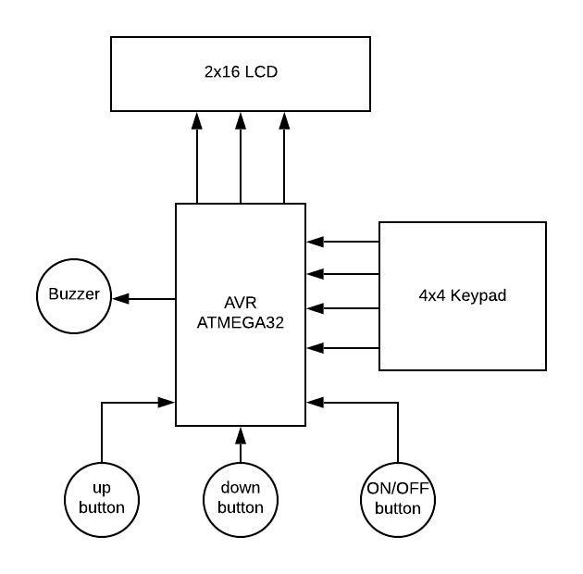

4. Hardware/Software specification

## ****4.1 Req _ DIGELV _HSI_01_V1.0****

**{**

**Enter user’s data.**

**Hardware needed:**

**- keypad**

**it’s used as input device to enter user’s name and password**

**- LCD (2*16)**

**It’s used as output device to display the user’s entered information**

**- Micro controller**

**The main component to write the software on**

**(2.1 Req _ DIGELV _CYRS_01_V1.0)**

**}**

## ****4.2 Req _ DIGELV _ HSI _02_V1.0****

**{**

**Display ok if the ID is correct, up and down buttons**

**- LCD**

**- 2 push buttons**

**(2.3 Req _ DIGELV _CYRS_03_V1.0)**

**}**

## ****4.3 Req _ DIGELV _ HSI _04_V1.0****

**{**

**Reset functionality**

**- Reset push button (on/off button)**

**(2.1 Req _ DIGELV _CYRS_05_V1.0)**

**}**